ARTIFICIAL INTELLIGENCE

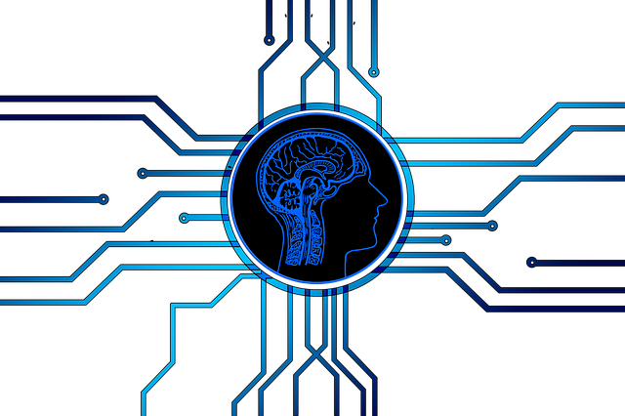 INT – 404

SIMPLE NAVIGATOR FOR LPU

|  |  |
| --- | --- |
| Kanaka Raju Gottumukkala | A21/11806904 |
| Sai Ram Ponnaganti | A22/11806910 |
| Ankit Yadav | A23 |
| Sai Ram Darapuneni | A24 |

Submitted to : Amandeep Kaur (Asst.

1.Introduction

Navigation is a field of study that focuses on the process of monitoring and controlling the movement of a craft or vehicle from one place to another. The field of navigation includes four general categories: land navigation, marine navigation, aeronautic navigation, and space navigation.

It is also the [term of art](https://en.wikipedia.org/wiki/Term_of_art)  used for the specialized knowledge used by [navigators](https://en.wikipedia.org/wiki/Navigator) to perform navigation tasks. All navigational techniques involve locating the navigator's position compared to known locations or patterns.

Navigation, in a broader sense, can refer to any skill or study that involves the determination of position and direction. In this sense, navigation includes [orienteering](https://en.wikipedia.org/wiki/Orienteering) and pedestrian navigation.

2.Objectives

The following are the objectives of the project of Simple Navigator for LPU :- The basic output of the project is that it should be able to predict out the accurate distance between the starting point to ending point and gives a time to reach out your destination . this project navigates the correct place in the University . and also easy to use so that you find your route from anywhere to anywhere inside the campus.

3.Methadology

Packages used in this Project :

GMaps : Stands for google maps it helps to add / delete the Places in the Map we also used the GMaps Dataset in Order to Configure/figure the Directions .

Sys : This is the inbuilt package in Python (we have to import) it helps us to use the Clipboard in Our System (Command Line Argument).

Web-browser : Web browser is also a package in Python it is used when we want to directs our output into the Browser we can go any Website by just running our Program .

Syntax : webbrowser.open(‘www.google.com’,+A)

It will Open the Google Search In this way we can go through any Website .

Pyperclip : Pyperclip’s major application in Python is to use the Clipboard , whenever we are running the Program it will Search for the Last copied word in Clipboard and it will Search that .

For Suppose we Copied “Lovely Professional University” this will stored in a Variable named A , It will directly Searches about the LPU .This Logic we were used to Seach Our Location .

API : **API** stands for application program interface. A programmer writing an application program can make a request to the Operating System using **API** (using graphical user interface or command interface). It is a set of routines, protocols and tools for building software and **applications**.

Excel : In this Project we used Excel files to Extract the Longitudes and Latitudes of Locations in LPU .

4.Results

38 Points (Locations) in Campus

Directions from BH-5 to CSE Block

Mode = Car (Driving)

Directions of Same Route by Walking

Information of Locations in Longitudes and Latitudes

5.Conclusion

It is a basic assumption-based software. it shows the starting point and the destination point from where the user would wish to go the steps are calculated and relatively the Time . here it calculates the distance in 3 modes By foot (B) ; Train (T) ; Bike (k)

Car (c) .

By the way of what user needs they proceed with the option

After Clicking the Train Option in the Navigation System You will redirected to the Google Train Search Sheet .

6.Future Scope

In the Present Scenario only we are merely depends on Google Maps to Travel from one Location to Another , the GMaps Algorithm updating and changing itself for every minute and hour depends upon the user inputs and the Conditions.

So In future means in the Upcoming Years Maps and Navigators will Play a key role in the life of Huma Beings .

This Project helped us to learn the Basics in Navigation System like GMaps(Package),API’s etc. It will definitely helps us in Future for further Purposes .